

Department of Electrical Engineering and Computer Science

Proposal for Senior Design Project

EEL 4914
Senior Design I

Robot Controller Interface Software

Group # 3

Michael Wales | Computer Engineer | NeedMoreHP@yahoo.com
Jeff Miller | Computer Engineer | j_miller68@hotmail.com
Jeff Goodman | Computer Engineer | goodmanj@orl.saic.com

Instructor: Dr. T. Kasparis

Spring/Summer 2001
The Robot Controller

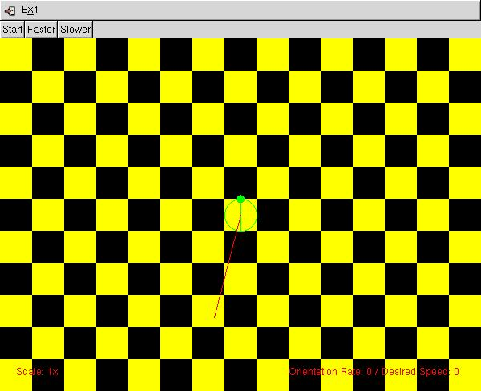

This program allows the user to directly interact with an actual robot or a robot surrogate through a graphical user interface (GUI). The GUI provides two methods for interacting with the robot or surrogate. The user can move the robot by using keyboard commands (for fine adjustments, good for close spaces) or by using mouse clicks.

To start the program type the name of the executable, but before you can start the robot software you must first create a text file called config.txt. There are three things in the config.txt file. They are the Server_IP, the Window_Size, and the port number. The robot surrogate and the robot controller both require the config.txt and should be identical.

Keyboard Commands

The keyboard allows the user to operate the steer motor and the drive motor directly on the robot. The GUI will not reflect any movements made by the user because the current robot does not implement a feedback system. The commands that are supported by the GUI are as follows:
Q or q = kill drive motor (sets drive motor rate to zero)
O or o = kill orientation motor (sets the orientation motor rate to zero)
Z or z = kill all (sets drive and orientation motor to zero)
W or w = increment robot speed (divisions of 5)
S or s = decrement robot speed (divisions of 5)
A or a = turn steer motor left (divisions of 5)
D or d turn steer motor right (divisions of 5)
Again, the only status information that will be updated on the GUI is the current orientation steer rate, and the current drive motor rate. The position of the robot on this screen is not accurate.

Mouse Clicks

The software also allows the user to specify a point to which they wish to direct the robot. This is done via mouse clicks on the checkerboard and setting the speed through the buttons on the GUI. Here is an example of a simple scenario that will have the effect of moving the robot to a desired point.
- User clicks on the point to which the robot is to be moved. This causes a line to be drawn from the current position (always the center of the screen) to the point clicked.
- Next the user must selected the desired speed with which the robot should move. Clicking on the faster and slower buttons provided on the GUI does this.
- Finally to make the robot move to the desired point the user must click the start button. The start button causes the robot to begin its change orientation turn. The GUI model of the actual robot will pause to allow time for the actual robot to turn. Once the signal is received that real robot has completed its turn, the GUI then begins to animate the robot’s movement. This is done in two ways.
- The point to which is moving moves towards the robot
- The background image of the GUI scrolls in the desired direction
- When the robot has reached the point that it was commanded to, the GUI automatically sends out a command which will stop any movement (set speed=0 orientation = 0). This command is very similar to the keyboard command for kill all.
To exit the program click the exit button located that the top of the GUI.

Note: Be sure to press the z button to send a kill all before exiting the program. If the robot is still running and the program is closed it will continue running.

The Robot Surrogate

The robot surrogate has many uses and can be uses to do several different things. The main use for the robot surrogate is to simulate the robot if you do not already have a robot or do not want to use the robot that you do have. Robots are very expensive and can be damaged easily or can cause severe damage to its physical surroundings. There would be no risk involved when using a robot surrogate for testing purposes that does not require the use of the actual robot. This will cause less wear and tear on the robot. Robots are also very large. Most buildings do not have a lot of extra space. The robot surrogate runs on a personal computer and does not take up space. If a user just wants to test a script that they wrote for the robot, the robot surrogate should act exactly the same way as the robot would and it would be much easier to run the surrogate than having to set up the robot to use.

The robot surrogate can also be used with the robot. If the robot that is being used is not visible to the user than the surrogate can be run along with the robot so the user knows where the robot is at all times. The robot could have a camera on it but the camera does not give the location so the surrogate is needed to let the user know the coordinates of the robot.

How to use the robot surrogate

Set the resolution to at least 800 x 600 (800 x 600 will display the robot most accurately). Before you can start the robot surrogate you must first create a text file called config.txt. There are three things in the config.txt file. They are the Server_IP, the Window_Size, and the port number. The robot surrogate and the robot controller both require the config.txt and should be identical. The Server_IP is the IP address of the computer being used for the robot controller. The Window_Size in the horizontal distance you want for the robot area in the robot surrogate. The port number is the network port. The Window_Size is the horizontal distance of the robot area. The aspect ratio of the robot display area is 1.6 to 1 (to explain vertical size of the robot area is equal to 1.6 * horizontal size).

The robot controller must be started before the robot surrogate is started (see above for details of the robot controller). The robot surrogate has to connect to the controller. If the controller is not already started, the robot surrogate will not be able to connect. If this happens, the following message will be displayed on the console “could not connect to robot controller.”

When the robot surrogate is connected to the controller, it is ready to receive commands. The user has the following options when the controller is started:
- Clear the location and speed list
- Scroll through the location and speed list
- Exit the program
To clear the location and speed list the user should click on the clear list button. The list will clear and new locations and speeds will begin to appear at the top of the list if the robot is in motion. The scroll window will allow the user to cycle through old locations and speeds to follow the path that the robot has taken. To exit the user should click on the exit button. This will first clear the location and speed list and then exit the program. Do not use the exit option in the top left of the GUI because this will not destroy all the threads.

The location and speed list displays the location and the speed of the robot. An example of the robot surrogate after moving for a while is shown below. The location is measured from the center of the robot area being the point (0.0, 0.0). If the user initializes the Window_Size to be 400 then the x coordinates would stretch from -200 to +200. The robot will always start at (0.0, 0.0) and cannot be changed. If you want the robot to start in the bottom corner than you should move the robot there by using the controller and clear the list. This would then show the robot in the bottom corner and the list would be empty so it would appear to be the same as starting the robot there originally. The robot will also always begin facing in the 90 degrees direction. 0 degrees is facing towards the right, 90 degrees is facing upward, 180 degrees is facing towards the left, 270 degrees is facing down, and 360 degrees is the same as 0 degrees.

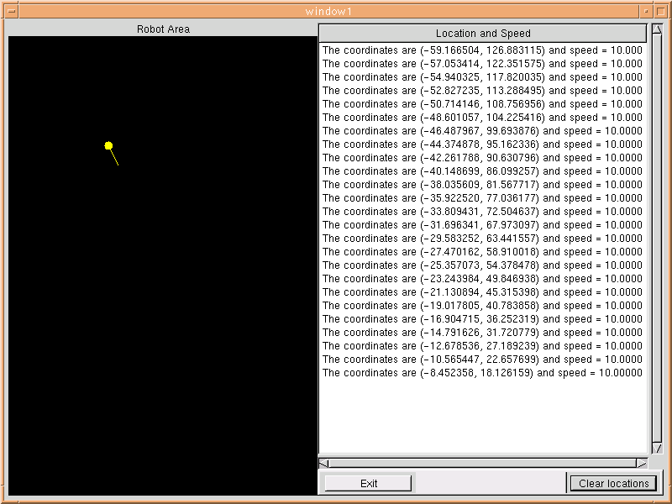

The robot has been traveling at a speed of 10 and is currently at the point (-59.166504, 126.883115)

The above picture is showing what the robot surrogate looks like after it has been moving for a short while at speed 10. The Window_Size during this simulation was set at 300. The clear location button was pressed prior to this screen shot. If it was not pressed than the bottom location would have read “The coordinates are (0.000000, 0.000000) and speed = 0.0000.” The robot was moving at an angle of 125 degrees

If the robot is told to go too far either in the x or y direction a message will be displayed in the location and speed list to let them know that the robot has gone too far. The reason that there are boundaries is if the real robot only has a fixed area to move around in, this will let you know that they have exceeded it. If the user is using the robot inside a building, they should set the boundaries according to the size of the room. If the robot exceeds the boundaries set by the user, the message will be displayed. This is a safety precaution to avoid collisions with the robot. An example of a collision like this is show below.

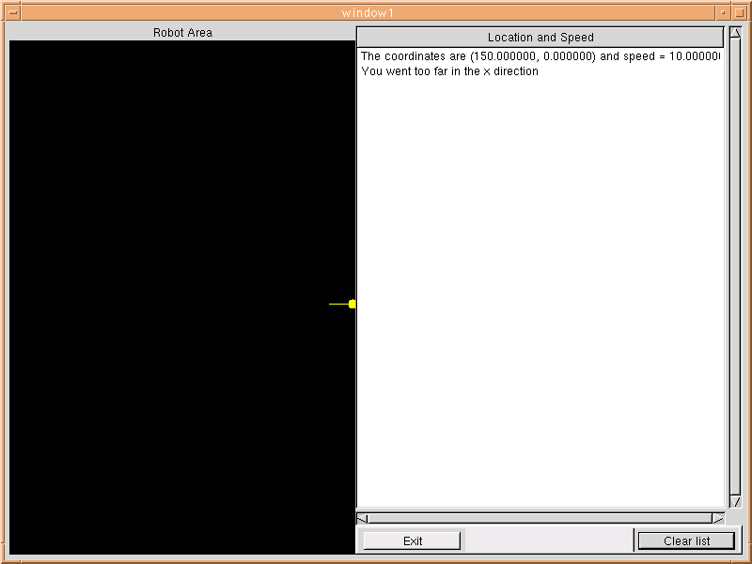

The robot went too far in the x direction so the message is displayed to let the user know to move the robot

CHECKLIST FOR OPERATING ROBOT/ROBOT SURROGATE

- Create confix.txt files
- Load robot controller
- Load robot surrogate
- Check to see if the connection was established
- If the robot seems to be moving too slowly clear the list
- Click the exit button when you wish to exit

Example of config.txt

Server_IP 127.0.0.1
Window_Size 400
Port 6543

Troubleshooting

Problem: Robot controller and robots are not connecting.

Solutions:
- Make sure the config.txt files on the systems match
- Check the network to make sure it is function properly
- Restart both programs and attempt to reconnect

